***Children with Special Educational Needs and Disability (SEND)***

***A Booklet for Parents***



SENDCo

Rachel Burke

**Definition of SEND**

‘Children have SEND if they have a learning difficulty or a disability which calls for SEN provision to be made for them.’ (Code of Practice 2014)

Children have a learning difficulty or disability if they:

1. Have a significantly greater difficulty in learning than the majority of children or the same age; or
2. Have a disability which prevents or hinders them from making use of educational facilities of a kind generally provided for children of the same age

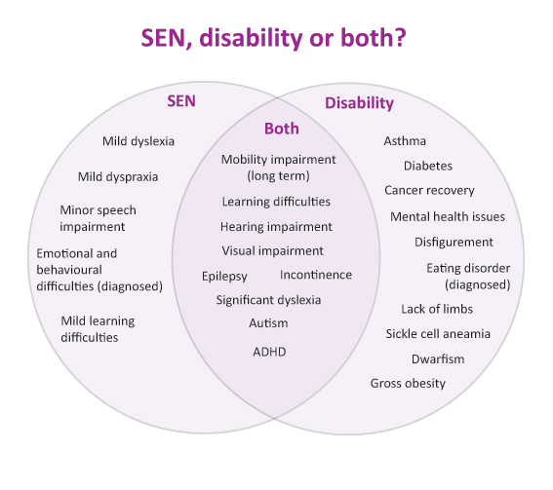

**Key staff in School who work with pupils with SEND**

* Teachers: Every teacher is a teacher of children with SEND. Class teachers provide high quality teaching through a planned curriculum that meets the needs of all the learners in their care. They are responsible for the progress of every child in their class and accountable for pupil outcomes.
* SENCo: Takes the lead in co-ordinating assessments and supports the planning of future interventions for the child in conjunction with colleagues and parents. This will include the monitoring and reviewing of actions taken and coordinating staff training. The SENCo also provides an additional communication point for parents.
* Teaching Assistants: Work under the supervision of class teachers and deliver specified work and planned programmes of work for many children including those with SEND. Some children may receive dedicated time from a teaching assistant and this will be outlined in an additional plan called Enhanced Provision.
* Family Support Workers: Are skilled in supporting children and families in challenging circumstances e.g. bereavement, struggling with behaviour at home, attendance of punctuality and families who may be working with other children’s services.

**Identification**

* Before a child starts at our school: Some children already have identified needs and these are discussed with parents and at visits to pre-school settings. Any review meetings arranged by the pre-schools in the term before children are admitted to St Gerard’s are attended by our staff.
* In school: All teachers are teachers of pupils with SEND and are responsible for identifying pupils with SEND as early as possible. This could be through teacher observation, teacher assessment, screening or assessment tools, data analysis and social and emotional support.
* Parent/Carers: This could be from information provided by parents/carers or in discussion with parents. Staff at our school recognises that parents know their children best and we are keen to discuss with them concerns or observations they have about their own children.

**Provision made for children with SEND**

Following identification, discussions and agreement with parents children are placed on the SEND register. There is now a single category of support termed ‘SEND support’.

Every school has a Special Educational Needs Register. The reasons children are on the Register vary greatly but fall into four broad areas identified in the Code of Practice.

1. Communication and Interaction including Speech and Language

2. Cognition and Learning

3. Social, Emotional and Mental Health Difficulties (previously Social and Emotional and Behavioural

Difficulties

4. Sensory and/or physical needs.

For the most part, children with SEND will be taught in the classroom, alongside their peers, receiving high quality teaching from the teacher. Teaching techniques and strategies within each class, including differentiated resources and learning tasks, will accommodate those of differing abilities, including those with SEND. When appropriate, children on the SEND register will sometimes have the additional support of a teaching assistant. This support might be delivered to an individual child on a one to one basis or within a group of children. By carefully monitoring the children, we can match their needs to differing programmes/interventions we have developed in school. Interventions are constantly reviewed and changed according to the needs of the children.

**Home/School partnership**

Parents are fully involved in the school based response for their child and are supported in playing an active role in determining future provision. Some ways parents of children with SEND are involved:

* Review meetings each term year
* Additional meetings if requested by parent of staff
* Sharing information through the SEND section on the school website
* Transitional reviews with pre-school and high schools.

**Outside Agencies**

We also work closely with other agencies and may seek further information on a child’s need and developmental profile. These include:

* Educational Psychologist
* Specialist Teacher Service
* Woodview Children’s Development Centre (NHS)
* Occupational Therapist/Physiotherapist

**Graduated Approach**

At St Gerard’s Primary School we follow the Graduated Approach. This can be considered as a process where increasing levels of support are implemented, and referrals are made to advisory services if school feel they need further support in matching the right type of support to a child. This can be demonstrated as:

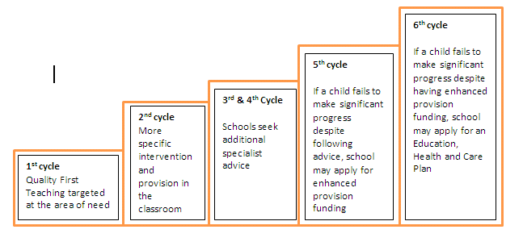

**Education Health and Care Plan (EHC Plan)**

Some children may require an EHCP Needs Assessment, in order for the local authority to decide whether it is necessary to make provision for the child, in accordance with an EHCP. The purpose of an EHCP is to meet the special educational needs of the child or young person. This is to secure the best possible outcomes for them across education, health and social care and, as they get older, prepare them for adulthood. This is for children with significant and complex SEND whose needs cannot be met by the resources of the school alone and often have a number of outside agencies involved. Young people and families worked with us and an ECHP co-ordinator to co-produce the design of the plan.

From September 2014 all Halton children and young people who have significant special educational needs and meet specific criteria within a graduated response, may undergo an Education Health and Care (EHCP) Assessment, which could lead to an EHC Plan.

An EHC plan replaces the Statements of SEN and Learning Disability Assessments; it is a personalised plan to meet the needs and outcomes for each child or young person. This will include what they think is important and what they want to achieve now and the future.

Further guidance for parents/carers can be found at:



<https://localoffer.haltonfamilyhubs.co.uk/send-home>

<https://localoffer.haltonfamilyhubs.co.uk/send-ehcp>

**Glossary of terms**

*Here are definitions of a few of the terms and abbreviations you might hear or read.*

* **SEN**: Special Educational Needs
* **SEND**: Special Educational Needs or Disability
* **SENCo/Assistant Hea Teacher for Inclusion**: Special Educational Needs Co-ordinator in the school
* **TA**: Teaching Assistant
* **FSW**: Welfare Supervisor
* **LA**: Local Authority
* **SEN Register**: The list of children who have SEND in a school
* **SEND support:** Children who are on the SEN register and don’t have an EHCP
* **EHCP:** Education, Health and Care Plan for children with significant/complex needs
* **Differentiation:** A way to teach pupils with different learning styles, different abilities to absorb information and different ways of expressing what they have learned.
* **Intervention:** Targeted support to accelerate learning in a specific curriculum area or to develop a skill which may be delivered to individual children or small groups of children. These will last for a specified length of time.
* **Review meetings**: For children on the SEN register there will be x3 review meetings each year. At these meetings staff and parents will agree longer term outcomes (usually yearly outcomes) and the steps children need to take in order to achieve these.
* **Outcomes:** Longer term objectives that parents, staff and children are working towards.
* **CAP**: Child Action Plan is the steps that children need to take in order to achieve the longer term outcomes.
* **Code of Practice:** Details of legal requirements that schools must follow without exception.