

St Gerard’s Catholic Primary and Nursery School

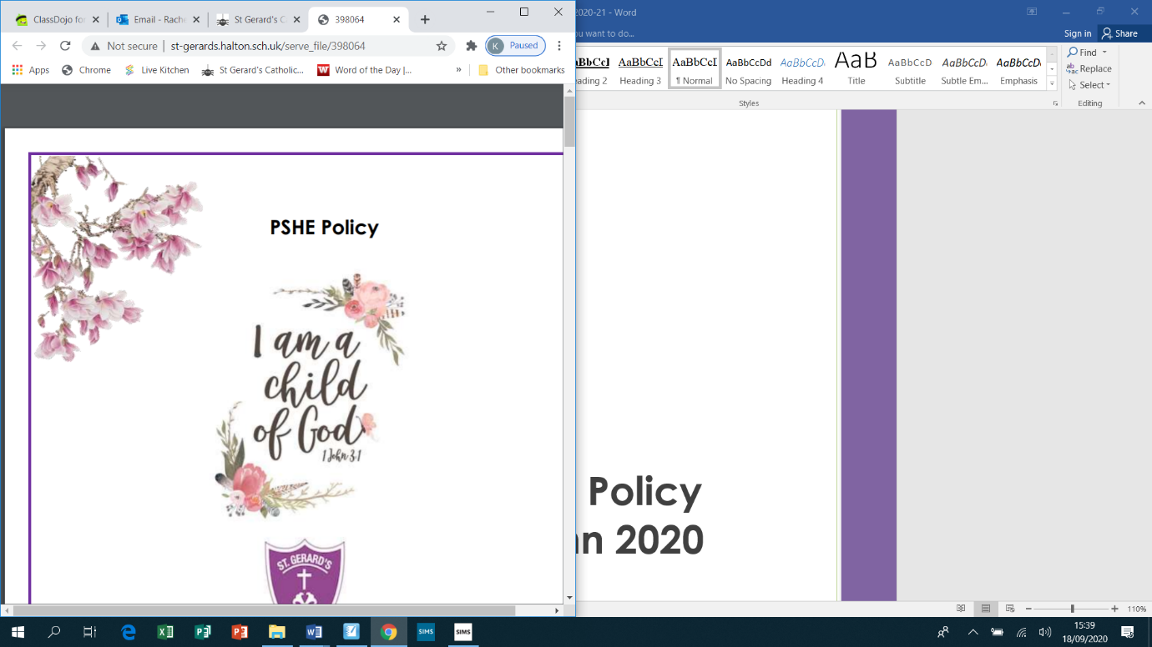

**Phonics Policy**



**SAFEGUARDING STATEMENT**



***“St Gerard’s Catholic Primary and Nursery School is committed to safeguarding and promoting the welfare of children***

***and young people and expects all staff and volunteers to share this commitment”.***

**Phonics Policy 2025-2026**

**Policy Date: September 2025**

**Policy Status: Statutory**

**Policy Review Cycle: Annual**

**Next Review Date: September 2026**

At St Gerard's we believe that Reading is the skill that opens the door to the rest of the curriculum; and to a world of knowledge! In order to become a confident, fluent reader children must have a secure understanding of the basic skills needed to decode words. The skills taught in phonics ensure that all children have the ability to read with accuracy and speed which in turn has a positive effect on children’s writing.

**Responsible to:**

**Governors, Head Teacher, Deputy Headteacher**

**Introduction:**

Our aim at St Gerard’s is for all our children to develop and secure the skills needed to become lifelong readers. Reading is a complex life skill which consists of many different components. It not only gives children the power and independence to access knowledge, but it is also a rewarding and enjoyable experience in itself. In order for children to read for meaning, phonic skills of decoding, segmenting and blending must be taught and built upon from the Early Years Foundation Stage, all the way through a child’s school journey to year 6. Although direct reference to British Values is not continuously made, the policy has been written with full awareness of our responsibility and commitment to this purpose.

**The aims of phonics are:**

* + To decode letter-sound correspondences quickly and effortlessly, using phonic knowledge and skills;
  + to read common exception words on sight;
  + to understand what they are reading;
  + to read aloud with fluency and expression;
  + to write confidently, with a strong focus upon vocabulary and grammar;
  + to spell quickly and easily by segmenting the sounds in words;
  + to acquire good handwriting.

**Teaching and learning:**

Phonics teaching takes place daily in differentiated groups. Pupils are grouped homogeneously, according to their progress in reading rather than their writing. This is because it is known that pupils’ progress in writing will lag behind progress in reading, especially for those whose motor skills are less well developed.  
  
In Reception we emphasise the alphabetic code. The pupils rapidly learn sounds and the letter or groups of letters they need to represent them. Simple mnemonics help them to grasp this quickly. This is especially useful for pupils at risk of making slower progress. This learning is consolidated daily. Pupils have frequent practice in reading high frequency words with irregular spellings – common exception words. We make sure that pupils read books that are closely matched to their increasing knowledge of phonics and the common exception words. This is so that, early on, they experience success and gain confidence that they are readers. Re-reading and discussing these books with the teacher supports their increasingly fluent decoding.   
  
Alongside this, the teachers read a wide range of stories, poetry and non-fiction to pupils; they are soon able to read these texts for themselves.   
  
Embedding the alphabetic code early on means that pupils quickly learn to write simple words and sentences. We encourage them to compose each sentence aloud until they are confident to write independently. We make sure they write every day.  
  
Pupils write at the level of their spelling knowledge. The quality of the vocabulary they use in their writing reflects the language they have heard in the books the teacher has read to them; they have also discussed what the words mean.   
  
Our aim is for pupils to complete the phonics programme as quickly as possible. The sooner they complete it, the sooner they will be able to choose books to read at their own interest and comprehension level.  
  
If a child arrives in Key Stage 2 reading below their chronological age or with English as an additional language they are taught Read Write Inc. Phonics until they too catch up with their peers. This is either within daily intervention groups in the afternoon, or with a KS1 group. Within upper KS2 (Years 5 and 6), this is taught through the Read Write Inc. ‘Fresh Start’ modules, which are phonically matched to children’s reading levels but are more age appropriate for children in years five or six.

**Phonics curriculum planning:**

Having monitored our Phonics data closely over the last five years, we have noticed that our data has plateaued. Often we see that children use their phonics skills in isolation and do not apply these when reading and writing in other areas of the curriculum. In order to address this issue, in September 2016 we have begun to use the ‘Read, Write, Inc’ phonics teaching programme. The programme directly meets all of the objectives in the National Curriculum. All staff have access to a ‘RWInc Handbook’ which has detailed planning for each stage of the programme. They also have teacher packs that contain the necessary resources needed.

**The Early Years Foundation Stage:**

Securing a strong understanding of the alphabetic code from an early age is an essential part of the reading process. Phonics begins as soon as children enter our school in Nursery. The simple mnemonics help children to learn new sounds speedily, and make strong links with writing and handwriting. Phonics is delivered daily in differentiated groupings, children are then encouraged to apply the skills they have learnt in other areas of the curriculum within continuous provision activities.   
  
A love of reading begins from an early age, as soon as children enter St Gerard’s we aim to encourage and promote reading for pleasure. The reading areas in Nursery and Reception are bright, cosy and inviting and children can access these regularly in continuous provision. Read Write Inc speed sounds charts and picture cards are clearly displayed in these areas to encourage children to use the skills they are developing when reading independently. Reading is planned for using the Development Matters Objectives.

**Contribution of phonics to teaching in other curriculum areas:**

**English:**

Phonics is an essential part of the reading process. Through the Read Write Inc programme strong links are made between phonics, reading and writing in order to encourage children to use the skills acquired to read speedily and spell accurately. Handwriting is also a key aspect of the programme, children are taught to write and orientate letters accurately through the use of simple mnemonics.

**Personal, social and health education (PSHE) and citizenship:**

The Read Write Inc programme teaches pupils to work effectively with a partner to explain and consolidate what they are learning. This provides the teacher with opportunities to teach team work, cooperation and respect for others.

**Science, Geography, History, ICT, DT, Art – ‘Topic’:**

The skills developed in phonics can be applied in all curriculum areas when children are required to read or write. They build speedy reading skills that allow them to access texts and gain information with ease. They also learn how to spell words accurately for writing. The focus on handwriting allows children to present their work neatly in all areas of the curriculum.

**Teaching phonics to children with special needs:**

We teach phonics to all children, regardless of their ability. Phonics forms part of our school curriculum policy to provide a broad and balanced education for all our children. Our teachers provide learning opportunities that are matched to the needs of children with learning difficulties. Work in phonics considers the targets set for individual children in their Individual Education Plans (IEPs). Specialised equipment, e.g. ‘Read, Write, Inc’ 1:1 support programmes are used to target those children who are having real difficulties with phonics.

**Assessment and recording:**

We assess all pupils following Read Write Inc. Phonics using the Sound and Word Entry Assessment. We use this data to assign them to homogenous Phonics groups. This gives us a very good indication of how well they are making progress relative to their starting points. We do this for all pupils, whenever they join us, so we can track all of them effectively, including those eligible for the pupil premium. We record their starting date and entry point on the tracker to monitor the rate at which they are making progress. We can also easily identify those who joined the programme later. We aim for all children to be accurate and speedy readers by the time they enter Key Stage 2. We have high expectations of our pupils’ progress.

**Resources:**

* + Teacher hand books
  + Fresh start Leader handbook
  + Phonics Leader handbook
  + Teacher packs including ‘speedy green words’ and flash cards
  + Colour banded reading books
  + Magnetic letters and boards
  + Oxford Owl website
  + Ruth Miskin website
  + Cal Tobin – Read Write Inc. consultant

**Monitoring and review:**

The monitoring of the standards of children’s phonics and of the quality of teaching in phonics is the responsibility of the English subject leader. The work of the subject leader also involves supporting colleagues in the teaching of phonics/Read Write Inc. and being informed about current developments in the subject. The English subject leader gives the headteacher an annual summary report in which she evaluates the teaching and learning in the subject, and indicates areas for further improvement.

**Agreed by Governing Body:**

**Date of next Review: September 2026**