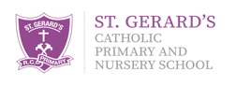

Pupil Parliament Minutes
Thursday 26th October 2023

Mrs Flint welcomed everybody.
Behaviour Policy:
- We agreed that as Pupil Parliament members, we should all set a good example.
- Display on doors and in classrooms.
- All agreed it was fair.
- Introduce by us at an assembly.
Dojo Shop:
- We think it is working well.
- Would like more things in like skipping ropes, Rubik’s cubes and fidget spinners.
Book Machine:
- Children would like non-fiction books included.
- Authors such as Tasmin Winter, Adam Blake, Roald Dahl, JK Rowling, David Walliams, Michael Morpurgo and Jeff Kinney.

