

**Modern Foreign Language Policy**

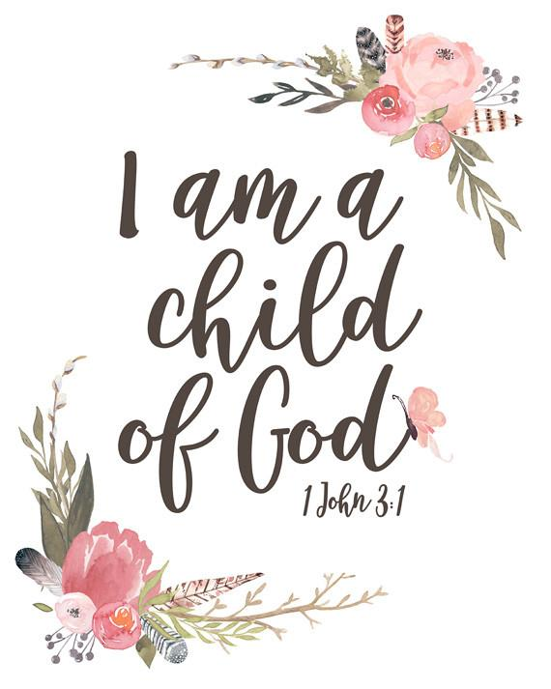





**St Gerard’s Catholic Primary School**

“Guided by God, St Gerard's Catholic Primary and Nursery

School is an inspiring and aspirational community where we

learn to love, hope, dream and achieve.”

**Policy Date:**  **October 2023**

**Policy Status:**  **Statutory**

**Policy Review Cycle:**  **Annual**

**Next Review Date:**  **October 2024**

The Subject Leadership role of MFL at St Gerard’s is central to improving outcomes for our children. Subject Leaders at St. Gerard’s have high expectations of themselves and our children, and are passionate about their specialisms. The lead for MFL shall ensure that the children thoroughly enjoy and partake in multiple experiences of MFL through teaching in lessons, external activities, external visits and residential visits.

****Responsible to:****

**Governors, Head Teacher, Deputy Head Teacher.**

**Purpose of study**

*“ Learning a foreign language is a liberation from insularity and provides an opening to other cultures. A high-quality languages education should foster pupils’ curiosity and deepen their understanding of the world. The teaching should enable pupils to express their ideas and thoughts in another language and to understand and respond to its speakers, both in speech and in writing. It should also provide opportunities for them to communicate for practical purposes, learn new ways of thinking and read great literature in the original language. Language teaching should provide the foundation for learning further languages, equipping pupils to study and work in other countries.”*

-The National Curriculum in England: Key stages 1 and 2 Framework Document. September 2013

**Context**

Children at St Gerard’s Catholic Primary and Nursery School learn Spanish. The school is a one form entry school with approximately 227 pupils. Over 70 children in the school are EAL students. In KS2 children are taught Spanish for 30 minutes per week and school aims to follow up activities when appropriate outside of the language lesson.

**Inclusion**

All children, regardless of background or any additional needs, have the right to a good quality education. Through differentiation and additional support, all children can enjoy learning a language, develop communication skills, discover more about the world and its diversity, and celebrate and appreciate cultural and linguistic differences. These skills can then be linked to and developed in other curriculum areas.

**Intent and Vision**

We believe that the learning of a language provides a valuable educational, social and cultural experience for our pupils, including those with special educational needs and/or disabilities. It helps them to develop communication skills, including the core skills of listening, speaking, reading and writing. The children’s knowledge of how language works, phonology and elements of grammar will be developed and extended. Lessons will enable pupils to make substantial progress in one language. The transferable language learning skills gained will assist and lay foundations for further language learning. It will provide pupils with the confidence and independence to explore and be able to attempt manipulation of the structure of language. Learning another language gives children a new and broader perspective on the world, encouraging them to understand their own cultures and those of others.

**Management and Training**

The subject is managed by the MFL Co-ordinator (Miss Roberts). To ensure the language skills of staff are developed and sustained the school are members of the Primary Languages Network. The PLN scheme of work is a thorough and ambitious scheme which ensures progression in language learning across the four core skills, the three pillars of progression (vocabulary, phonics and grammar) and also the DfE 12 Attainment Targets. The co-ordinator will advise, work with and guide staff and the visiting specialist teacher when required.

**Implementation – Curriculum**

Our school follows the Primary Languages Network scheme of work (Click2Teach/Video2Teach). It is a live scheme which is continually updated and revised in order to meet with current curriculum standards. It holds at its core the Intent, Implementation and Impact of MFL whilst maintaining a ‘primary’ focus. Alongside the planning provided, the scheme is supported by accompanying videos, PowerPoints, audio files (spoken by native speakers), links to authentic literature, songs, games, cultural points of reference, seasonal events and cross-curricular links.

The children in KS2 build up their knowledge and skills by working through the language learning stages from Stage 1 in Year 3 to Stage 4 in Year 6. The scheme of work is progressive, with the foundations being laid in Stages 1 and 2, ready for further development and challenge in Stages 3 and 4.

**Implementation - Teaching and Learning**

To promote an active learning of languages a range of teaching methods are implemented to ensure that the children are developing their linguistic skills through listening, speaking, reading and writing in order to be secondary ready. Activities can consist of actions, rhymes, stories, song, drama, grammar focus, video clips, air writing, sentence structure, dictionary work, book making and many more creative ways to extend, embed and combine language skills. Written work is kept in workbooks, although formal writing is not the outcome of every lesson. The skill of writing is developed through use of whiteboards and air writing leading to writing in books.

**Impact**

Our curriculum is planned to demonstrate progression both in core skills and language learning skills. Assessment for learning takes place during lessons in order to evaluate and provide immediate feedback to improve further. Errors are corrected by being ‘re-framed’ and growth mindset is encouragement for all to ‘have a go’ and learn from any mistakes. Pupils self-assess each learning objective using PLN’s self-assessment cloud documents. There are inbuilt opportunities to carry out summative assessment (Puzzle It Out) three times during the year in listening, speaking, reading and writing in order to track progress. The aim is for a core body of language (words and phrases) to be ‘left in the sieve’ (as quoted by Dr Michael Wardle, HMI Lead for Languages) by the end of each stage.

Through the use of Puzzle It Out assessments and the tracking of results using a spreadsheet, progress can be monitored, and show the impact of language learning. The outcomes of these assessments allow staff to identify any of the core skills which still need developing and any areas of content which need further reinforcement.

**Monitoring and CPD**

The MFL coordinator discusses language learning with the visiting teacher and monitors planning and spoken and written evidence of progress in learning through book scrutiny, pupil voice opportunities and discussion with staff. The lead teacher can access training via the PLN VLE , consultation time, email discussion and through the PLN CPD Journey.

The MFL Coordinator is engaged with the PLN CPD journey and has attended the Effective Coordination session, regularly attends the Leadership Twilight and is a member of the PLN Forum WhatsApp group.

The MFL coordinator attends the annual PLN conference, and can access the PLN Twitter account, the PLN website: www.primarylanguages.network, and the PLN VLE blog to obtain current and up to date information. All staff have access to the PLN VLE and all its materials. The PLN VLE school user files can be used to share information between staff and the visiting teacher.

**Accountability**

An annual action plan and termly summary report is produced for the Leadership team. These are then summarised by the Leadership team member with responsibility for the curriculum and shared with the Governing Body.

To be read in conjunction with the following policies:

* Teaching & Learning Policy
* Marking & Feedback Policy
* Curriculum Policy
* Assessment Policy
* Behaviour for Learning Policy
* Subject Leadership Policy
* Safeguarding Policy

**Agreed by Governing Body:**

**Date of next Review: October 2024**