**Maths Policy**

**2021-2022**

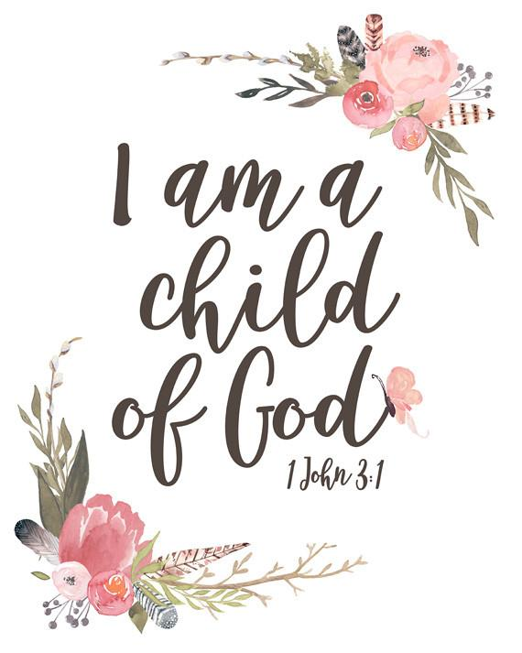



**St Gerard’s Catholic Primary School**

*“Guided by God, St Gerard's Catholic Primary and Nursery School is an inspiring and aspirational community where we learn to love, hope, dream and achieve.”*

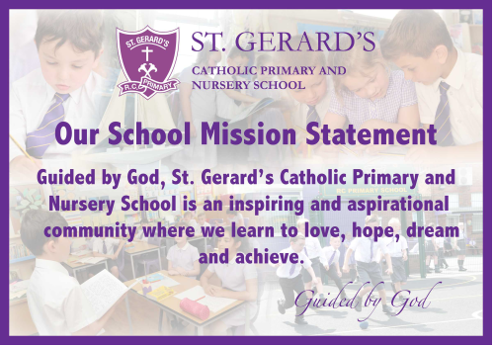

**SAFEGUARDING STATEMENT**



***“St Gerard’s Catholic Primary and Nursery School is committed to safeguarding and promoting the welfare of children and young people and expects all staff and volunteers to share this commitment”.***

**“Mathematics knows no races or geographic boundaries; for mathematics, the cultural world is one country.”**

**David Hilbert, Mathematician**

**Policy Date: October 2021**

**Policy Status: Statutory**

**Policy Review Cycle: Annual**

**Next Review Date: October 2022**

The Subject Leadership role of Mathematics at St Gerard’s is central to improving outcomes for our children. Subject Leaders at St. Gerard’s have high expectations of themselves and our children, and are passionate about their specialisms. The lead for Mathematics shall ensure that the children thoroughly enjoy and partake in multiple experiences of Mathematics through teaching in lessons, external activities, external visits and residential visits.

**Responsible to:**

**Governors Head Teacher, Deputy Headteacher**

**Introduction:**

Mathematics is a creative and highly inter-connected discipline that has been developed over centuries, providing the solution to some of history’s most intriguing problems. It is essential to everyday life, critical to science, technology and engineering, and necessary for financial literacy and most forms of employment. A high-quality mathematics education therefore provides a foundation for understanding the world, the ability to reason mathematically, an appreciation of the beauty and power of mathematics, and a sense of enjoyment and curiosity about the subject

**The aims of Mathematics are:**

The national curriculum for mathematics aims to ensure that all pupils:

* become **fluent** in the fundamentals of mathematics, including through varied and frequent practice with increasingly complex problems over time, so that pupils develop conceptual understanding and the ability to recall and apply knowledge rapidly and accurately.
* **reason mathematically** by following a line of enquiry, conjecturing relationships and generalisations, and developing an argument, justification or proof using mathematical language
* can **solve problems** by applying their mathematics to a variety of routine and non-routine problems with increasing sophistication, including breaking down problems into a series of simpler steps and persevering in seeking solutions.

Mathematics is an interconnected subject in which pupils need to be able to move fluently between representations of mathematical ideas. The programmes of study are, by necessity, organised into apparently distinct domains, but pupils should make rich connections across mathematical ideas to develop fluency, mathematical reasoning and competence in solving increasingly sophisticated problems. They should also apply their mathematical knowledge to science and other subjects.

The expectation is that the majority of pupils will move through the programmes of study at broadly the same pace. However, decisions about when to progress should always be based on the security of pupils’ understanding and their readiness to progress to the next stage. Pupils who grasp concepts rapidly should be challenged through being offered rich and sophisticated problems before any acceleration through new content. Those who are not sufficiently fluent with earlier material should consolidate their understanding, including through additional practice, before moving on.

**Teaching and learning**

At St Gerard’s Roman Catholic Primary School, we strive to develop resilient mathematical thinkers. We aim for our children to be independent, confident, willing to have a go and to develop skills to equip them for their future. The teaching and learning of Maths is informed and reflective of Catholic thought and practice.

Everything we do in mathematics at St Gerard’s is underpinned by the aims of the national curriculum which are:

* Place value and number
* Addition and subtraction
* Multiplication and division
* Fractions
* Measurement
* Geometry
* Statistics

We give our children high quality mathematical experiences to develop conceptual understanding and enhance reasoning and problem solving skills. We do this by:

* Morning Maths – children in each class will spend ten to fifteen minutes at the beginning of each day to develop arithmetic proficiency. This will include practice of counting, multiplication and related division facts, number bonds and calculation skills. This work may be recorded in a daily ‘Morning Maths’ book. These sessions can involve a range of practical activities and use of online resources for example www.minimaths.co.il
* Structure of daily maths lessons:
  + Hook – a short challenge question for children to work on independently or in pairs which promotes mathematical thinking and problem solving and reasoning. It is linked to the main focus for the lesson. This gives opportunity for all staff to observe and listen to pupils and identify misconceptions and good examples.
  + Share – class teacher uses this short part of the lesson to share good examples and address any misconceptions from the hook. There is a focus on developing mathematical vocabulary and the opportunity for children to explain their mathematical thinking.
  + Modelling – In this part of the lesson the teacher builds upon the shared ideas and focusses upon the main objective for the lesson. The teacher and pupils will use concrete resources and visual representations.
  + Practice – children will work independently and in groups to apply and develop their learning. This will include appropriately pitched challenges which incorporate reasoning and problem solving skills. During this part of the lesson the adults will provide immediate feedback to learners and make informal assessments based on their observations. Where children are identified as having significant difficulties with the objective this will be recorded in the ‘Pick-me-up book’ for further intervention.
* Planning for learning – Liverpool planning will be used to guide the curriculum across the year. These resources will be supplemented with Build a Sequence, White Rose, Nrich and NCETM materials which are available on the teachers share drive. Short term plans will be recorded on the school planning format which will include identification of both concrete and visual resources that will be used within each lesson.
* Calculation policy – each member of staff has a copy of the calculation policy which is referred to when planning for learning.
* Marking – each member of staff has a copy of the marking policy which outlines marking expectations.

**Maths curriculum planning**

Our medium-term plans have been designed by our class teachers and maths coordinator with the support of First4Maths specialists using NCETM approaches. These documents are then used to support in delivering high-quality maths lessons that promote mastery teaching. These plans define what we will teach and ensure an appropriate balance and distribution of work across each term. Each class teacher is responsible for developing and using the planning overviews. Copies are available to the Subject Leader

Class teachers complete a weekly plan which includes at least five lessons. These list the specific learning objectives for each lesson and give details of how to teach the lessons. The class teacher keeps these individual plans, and the class teacher and subject leader often discuss them on an informal basis.

We plan the activities in Maths so that they build upon the prior learning of the children. We constantly assess and tailor our plans to meet the needs of the individual. This is supported through relevant homework.

**Curriculum ‘catch up’**

Following the reopening of school, using the ‘Teaching Mathematics in Primary Schools’ document (Department for Education), Maths learning will be weighted towards the essential skills referenced as ‘Ready to Progress’ objectives and prerequisite knowledge where applicable. These are skills deemed most essential for progression in Maths.

This document has been analysed and planned into our medium term plans to ensure they link coherently with National Curriculum objectives.

Our Morning Maths time has been extended to allow all children to focus on arithmetic skills to build proficiency. Children will complete Morning Maths daily followed by mathematical discussion with their class teacher to build these skills.

All children complete Maths homework weekly which will focus on those skills that have not been taught last year to ensure further prerequisite-knowledge coverage.

All subject leaders in school are continuing to analyse cross-curricular links with Maths to ensure further opportunities to cover Maths skills. A particular focus has been placed on PE where pupils will cover shape and measure objectives using ‘Teach Active’ (Maths of the Day).

**Teaching of Maths**

In the Foundation Stage, children are given the opportunity to develop their understanding of number, measurement, pattern and shape and space through a combination of short, formal teaching as well as a range of planned structured play situations, where there is plenty of scope for exploration.

Our EYFS team have been working with the North West Maths Hub on the ‘Developing Mathematical Fluency’ programme. Within this programme, our aims are to ensure that our EYFS practitioners use the principles and pedagogies of EY best practice to ensure that all children are provided with access to deep mathematical learning across the environment, appreciating and understanding how pedagogy used in EYFS aligns with effective teaching for mastery. We are also excitied to be working with our local Maths Hub in their ‘Mastering Number’ programme which aims at improving teaching for mastery approaches in EYFS and KS1

Maths learning builds from a concrete understanding of concepts where children are manipulating objects. When children are able to see concepts this way, they then need to understand the same concepts represented pictorially. Children are then ready for abstract representation before being able to apply their knowledge to different situations.

We provide a rich environment in which we encourage and value creativity. Children experience a wide range of activities that they respond to, using the various senses. We give them the opportunity to work alongside other specialist adults. The activities that they take part in are imaginative and enjoyable.

**Contribution of Maths to teaching in other curriculum areas**

**Science**

Maths and Science are closely related. Charts, data and graphs are common in both subjects and the ability to create, read and interpret these is crucial. Geometry and algebra can also help pupils understand more complex scientific models.

**Personal, social and health education (PSHE) and citizenship**

Maths contributes significantly to the teaching of personal, social and health education and citizenship. Children develop self-confidence and resilience by having opportunities to explain their answers and reasoning.

**PE**

Pupils will need to link pattern, movement and time to enable them to perform high-quality routines. These cross-over elements are developed first in Maths lessons. Pupils will also use statistical data to develop their athletic performance and will need to analyse this data accurately. Our school also follows ‘Maths of the Day’ which is an active maths programme. Our sports coach delivers this in KS1 and KS2 focussing on number. As a result of this approach, pupils are receiving an extra hour of Maths every week while still achieving key skills in Physical Education.

**Music**

Music makes significant use of symbols as does Maths. Both Music and Maths require counting skills in order to be able to access learning. Repeating patterns in Maths will help pupils access repeating patterns in Music. Pupils in Year 1 are also receiving weekly ‘Numeracy in Music’ sessions delivered by the Accent Music Hub.

**Computing**

Pupils will explore directions, steps and symbols in programming lessons. This may include language heavily associated with mathematical reasoning such as ‘what if?’ Condition selection has its roots in mathematical language. Pupils will create, interpret and understand data in many variants.

**Geography and History**

Both subjects require the ability to create and interpret data. Maps use keys and symbols which pupils will become familiar with in Maths lessons. Being able to understand what a graph is for is a crucial elements and objective common in both disciplines.

**Art and Design**

Art incorporates ratio, proportion, shape, translation, measure and symmetry. All of these areas can be developed in Maths and Art to support and enrich learning in both subjects. The ability to measure, scale and reason are crucial skills in Design. Problem solving, a key requirement of Maths, features heavily in Design lessons.

**Spiritual, moral, social and cultural development**

Groupings allow children to work together and give them the chance to discuss their ideas and feelings about their own work and the work of others. Their work in general helps them to develop a respect for the abilities of other children and encourages them to collaborate and co-operate across a range of activities and experiences. The children learn to respect and work with each other and with adults, thus developing a better understanding of themselves.

**Teaching Maths to children with special needs**

We teach Maths to all children, whatever their ability. Maths forms part of our school curriculum policy to provide a broad and balanced education for all our children. Children who require additional support are identified on both the year groups’ provision maps and the teachers’ mathematics plans. Needs for these children are met through differentiated activities and adult support when appropriate. This can take place both during the mathematics lesson and through an additional intervention.

**Assessment and recording**

We assess the children’s work in Maths whilst observing them working during lessons and through assessment. Teachers record the progress made by children against the learning objectives for their lessons. At the end of a unit of work we make a judgement against the National Curriculum skills identified as ARE. The teacher records the child’s attainment, and then uses this information to plan future work for each child. This method of recording also enables the teacher to make a regular assessment of progress for each child which can then inform part of the child’s annual report to parents. We pass this information on to the next teacher at the end of each year.

Class teachers record pupil assessment on a tracking system and this will show progress and areas covered. Other evidence is kept through the year floor book by the class teacher/support staff. Evidence will also be collated through school and class displays, the website and Twitter feeds. This demonstrates what the expected level of achievement is in Maths in each year of the school. Teachers meet regularly to review individual evidence of children’s work against the national exemplification material produced by the DfE.

**Resources**

We have a range of resources to support the teaching of Maths across the school. We have a wide range of concrete resources for the pupils to access independently or as directed by an adult. An audit of resources will be completed termly by the Maths team and an order will be given to the school office to replenish the resources. Specialist materials will be supplied by any specialist partners that deliver any learning or activities across the year groups.

**Monitoring and review**

The monitoring of the standards of children’s work and of the quality of teaching in Maths is the responsibility of the Maths leader. The work of the subject leader also involves supporting colleagues in the teaching of Maths and being informed about current developments in the subject. The Maths subject leader gives the headteacher an annual summary report in which he evaluates the teaching and learning in the subject, and indicates areas for further improvement. The Maths subject leader has specially-allocated regular management time, which he uses to review evidence of the children’s work, monitor assessments and when instructed by SLT to undertake lesson observations of Maths teaching across the school.

All activities and visiting partners will adhere to our Safeguarding policy and procedures.

**Accountability**

An annual action plan and termly summary report is produced for the Leadership team. These are then summarised by the Leadership team member with responsibility for the curriculum and shared with the Governing Body.

**Sharing learning with parents:**

Every week science work will be shared using social media so parents/carers can see the learning that has taken place. All science work will be visible using the hashtag ‘**#StGerardsMaths’.**

**The Role of the Maths Co-ordinator:**

· To review changes to the National Curriculum requirements and advise on their implementation.

· Attend relevant CPD courses for Maths as appropriate in line with the School Development plan.

· Arrange staff meetings to discuss the scientific aspects of the themes contained in the school’s current scheme of work and how these might be presented in the classroom.

· Carry out an annual audit of the school’s Maths resources, and operate an efficient storage system for these resources to ensure that our children can learn effectively in and through Maths.

· Liaise with the school’s SENDCO regarding the progress of individual and groups of children.

· Monitor the learning and teaching in Maths and provide support for staff when necessary.

· Take a lead role in organising Maths events in school in line with LA and national initiatives.

· Endeavour to involve parents/carers in their children’s learning in and through science.

The Maths Subject Leader will monitor pupil progress, books and the teaching of Maths during the academic year. The Subject leader will provide a termly report to Mrs McCallum (Curriculum Lead) and a full review of the subject will be provided of each academic year.

**Agreed by Governing Body:**

**Date of next Review: October 2022:**